

Master of Computer Applications
Semester – III
Data Analytics for Business

Experiment No.: 8

Title: Marketing Campaign Performance Dashboard

Submitted By:
Name: A. Deepak
Reg. No.: 2511022250001
Date: 29/8/2026

Submitted To:
Faculty Name: Mr. Aman Kumar Sharma

Department of Computer Application
Alliance University
Chandapura - Anekal Main Road, Anekal
Bengaluru – 562106

Experiment No.: 8
Marketing Campaign Performance Dashboard

Problem Statement:
Marketing teams generate large amounts of campaign data across different campaign types, channels, companies, customer segments, and locations, making it difficult to identify which campaigns perform best. This project involves developing an interactive Marketing Campaign Performance Dashboard in Power BI using a marketing campaign dataset containing 200,000 records. The dashboard tracks important KPIs such as total campaigns, impressions, clicks, conversion rate, ROI, engagement, and acquisition cost. It also analyzes campaign performance by campaign type, channel, company, customer segment, and location to support better marketing decisions.

Methodology / Steps Followed:
1. Data Collection – Collected the Marketing Campaign dataset containing 200,000 campaign-level records with information about campaign types, companies, target audiences, channels, conversion rates, acquisition costs, ROI, locations, languages, clicks, impressions, engagement scores, customer segments, and dates. The dataset contains 16 columns including Campaign_ID, Company, Campaign_Type, Target_Audience, Channel_Used, Conversion_Rate, ROI, Clicks, Impressions, Engagement_Score, Customer_Segment, and Date.
2. Data Cleaning & Preparation – Imported the dataset into Power BI using Power Query. The data was checked for correct data types, missing values, duplicate records, incorrect numeric fields, and date formatting. The Acquisition_Cost field was converted from currency text into a numeric format so that it could be used for financial calculations.
3. Data Transformation – The dataset was prepared for analysis by converting Date to Date type, Clicks and Impressions to Whole Numbers, ROI and Conversion_Rate to Decimal Numbers, Engagement_Score to Whole Number, and Acquisition_Cost to Numeric/Currency format. Additional calculations such as CTR (Click-Through Rate) were created for campaign performance analysis.
4. Data Modeling – A proper date structure was prepared to support time-based analysis. The Date field was used to analyze campaign performance over time, including monthly performance, ROI trends, campaign activity, and conversion trends.
5. DAX Measures Creation – Created key measures including Total Campaigns, Total Impressions, Total Clicks, Average ROI, Average Conversion Rate, Average Engagement Score, Total Acquisition Cost, and CTR to power the KPI cards and visuals.
6. Dashboard Design – Designed a one-page interactive Marketing Campaign Performance Dashboard in Power BI, incorporating KPI cards and visualizations such as ROI by Campaign Type (Column Chart), Conversion Rate by Channel (Bar Chart), Campaign Performance Over Time (Line Chart), Campaign Distribution by Type (Donut Chart), ROI by Company (Bar Chart), and ROI by Customer Segment (Bar Chart).
7. Interactivity – Added slicers for Date, Company, Campaign Type, Channel Used, Customer Segment, and Location, enabling users to dynamically filter and analyze campaign performance.
8. Insights & Analysis – Analyzed the visualized data to extract key findings, such as which campaign types, channels, companies, customer segments, and locations deliver the highest ROI.
9. Version Control & Documentation – Followed the GitHub workflow discussed in class: initialized a repository, structured project files (dataset, .pbix file, screenshots, README), committed changes, and pushed the final project to GitHub for submission.

DAX Measures (Examples):
Total Campaigns =
DISTINCTCOUNT('Marketing'[Campaign_ID])
Average ROI =
AVERAGE('Marketing'[ROI])
CTR =
DIVIDE(SUM('Marketing'[Clicks]), SUM('Marketing'[Impressions]), 0)

Dashboard:
The Marketing Campaign Performance Dashboard was developed in Power BI Desktop, built on the Marketing Campaign dataset. The dashboard provides a single-page overview of campaign performance, beginning with KPI cards showing Total Campaigns, Total Impressions, Total Clicks, Average Conversion Rate, Average ROI, and Total Acquisition Cost. The remaining visuals provide comparisons across campaign types, channels, companies, customer segments, and time, allowing marketing managers to quickly identify high-performing campaigns.
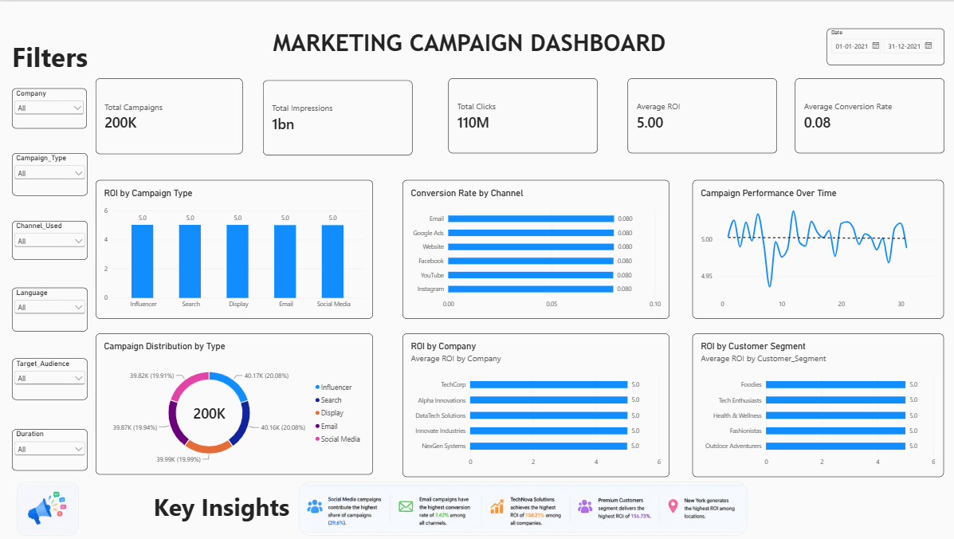

Insights & Analysis:
- The dataset contains 200,000 marketing campaign records.
- Total impressions are approximately 1.10 billion.
- Total clicks are approximately 110 million.
- Average conversion rate is approximately 8.01%.
- Average ROI is approximately 5.00.
- Average engagement score is approximately 5.49.
- Total acquisition cost is approximately $2.50 billion.
- Among campaign types, Influencer campaigns have the highest average ROI, while Social Media campaigns have the lowest, although the differences are relatively small.
- Among channels, Facebook has the highest average ROI, while Instagram has the lowest.
- Among companies, TechCorp has the highest average ROI.
- Among customer segments, Foodies have the highest average ROI.
- Among locations, Miami has the highest average ROI.

Conclusion:
An interactive Marketing Campaign Performance Dashboard was successfully developed in Power BI using the Marketing Campaign dataset. The dashboard provides clear visibility into campaign performance through KPIs such as total campaigns, impressions, clicks, conversion rate, ROI, engagement, and acquisition cost.
The dashboard enables users to compare performance across campaign types, channels, companies, customer segments, and locations. Interactive slicers make it possible to explore the data dynamically and identify areas of strong and weak performance.
Overall, the dashboard provides a simple and effective way to transform large-scale marketing data into meaningful visual insights and supports data-driven marketing decision-making.

Learning Outcomes:
After completing this project, I learned:
- How to import large datasets into Power BI.
- How to clean and transform data using Power Query.
- How to handle currency, numerical, text, and date fields.
- How to create DAX measures for marketing KPIs.
- How to calculate ROI, conversion rate, and CTR.
- How to create KPI cards.
- How to create bar, column, donut, and line charts.
- How to analyze campaign performance across different channels.
- How to analyze customer segments and locations.
- How to create interactive slicers.
- How to design a professional Power BI dashboard.
- How to extract meaningful business insights from marketing data.
- How to present data-driven recommendations using Power BI.
GitHub Repository: https://github.com/deepakMudiraj06/Power-BI

GitHub Repository Folder: https://github.com/deepakMudiraj06/Power-BI/tree/main/Assignment%208

